
Student Exchange Program Fact Sheet
Spring Semester 2020

Institution Information
Name of institution |  | Kwangwoon University (KWU)
Contact information |  | Name | Sunae Han  (Coordinator)
 |  | Department | Office of International Affairs
 |  | Email | sunae_01@kw.ac.kr
 |  | Website | http://www.kw.ac.kr/en
 |  | Telephone | +82-2-940-5014
 |  | Fax | +82-2-940-5016
 |  | Address | 111 Munhwa Bld.,  20 Kwangwoon-ro, Nowon-gu,  Seoul 01897, South Korea
2019 Academic Calendar
Recommended arrival dates (airport pickup) |  | 17-18 Feb.  * Please make sure to send a scanned copy of your flight ticket to sunae_01@kw.ac.kr 2 weeks before the arrival date. Students must arrive in Korea on the designated day for free pickup.  (There are two airports – Incheon and Gimpo Airport. Please make sure to arrive at the airport before 3 pm)
Programs open to exchange students |  | spring semester 2020
Spring semester period |  | 2 Mar. ~ 19 Jun.
Orientation dates |  | 19 Feb.  If you do not attend the orientation, admission to study at Kwangwoon University can be revoked. *
Application Procedure
Nomination deadline | November 1st for spring semester
Application deadline | November 15th for spring semester
Language requirements | Certificate of language proficiency:  English (TOEFL IBT 61, IELTS 5.0, etc.) or  TOPIK (Test of Proficiency in Korean) 4 Level or  proof of min. 2 Korean courses completed
Visa requirements | D-2 Visa
Duration of process | 1 month
Application documents  (Please scan document ①-⑤ together and send to sunae_01@kw.ac.kr  : 1 pdf file for 1 student) | ① Completed application form  ② Certificate of University Enrollment (English)  ③ Official academic transcript (English)  ④ Copy of Passport  ⑤ Certificate of English proficiency test (TOEFL, IELTS, TOEIC or  Other English proficiency certificates) or certificate of TOPIK  (or proof of minimum 2 Korean courses completed)
Dormitory
https://dorm.kw.ac.kr
Application deadline | November 15th for spring semester
Fee | KRW 1,662,160 (include KRW 100,000 for deposit / semester)  Students can only pay by cash.
Meal | Not provided
Student number in a room | 2
Facilities | - Room: beds, desks, wardrobes, bathroom, air-conditioner  - Public facilities: washing machine, fitness room, kitchen, seminar  rooms, delivery compartment, convenience store
Document | - Must bring results of chest X-ray for checking status of pulmonary tuberculosis
Note | - Students need to bring or buy blankets, pillows, and bed spreads by themselves.  - Students can stay until Aug. 5, 2020 only (tentative)  - If students arrive earlier than the recommended arrival date, they need to find their own temporary accommodation.
Pictures | 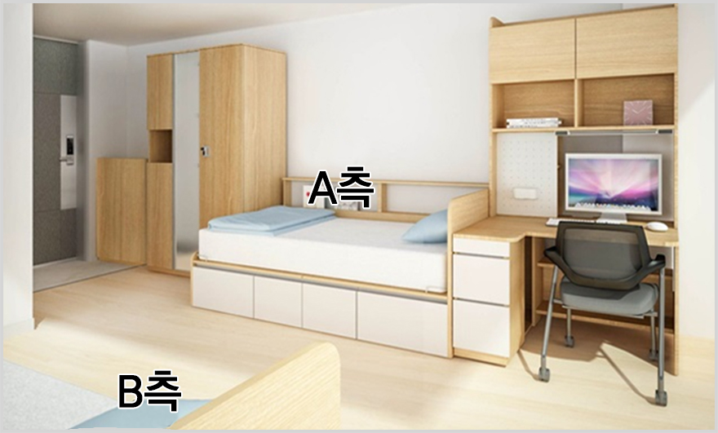
Insurance and Additional Information
Terms & Conditions | It is mandatory to buy insurance. Students can either purchase insurance in their home country if the contract is written in English for us to verify or buy designated insurance of KWU in Korea after arrival.
Insurance fee | KRW 60,000 for 6 months
Terms and conditions of insurance | Further explanation will be provided during our orientation
Buddy Program | Student can apply for Buddy Program within 1~2 weeks after arrival
Orientation contents | ① Campus & library tour ② Korean language level test  ③ Registration of courses ④ Additional information
Visa | Make sure to receive your visa prior to arrival in home country, especially students from European countries.

