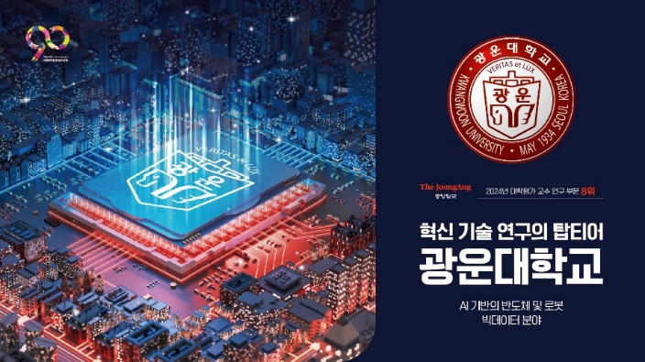

Kwangwoon University
Student Exchange Program
FACT SHEET
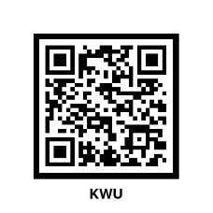

1. KWU Quick Overview
Foundation | 1934
Motto | Veritas, Lux
Student Number | Undergraduate : 8,414  Graduate : 1,646  International : 1,126
Faculties/Departments | Undergraduate | 9 Faculties, 36 Departments  https://www.kw.ac.kr/ko/univ/glance.jsp
Faculties/Departments | Graduate | 29 Departments  https://www.kw.ac.kr/en/graduate/graduate01_1.jsp
International Partnership | 27 Countries, 133 Institutions  https://www.kw.ac.kr/ko/status/partner_univ.jsp
Website | https://oia.kw.ac.kr/exchange/inbound.php

2. Point of Contact
Name | Soobeen Choi (International Exchange Coodinator)  Office of International Affairs
Email | soobeen.choi@kw.ac.kr
Telephone | +82-2-940-5014
Address | 103 Hwado Hall, 20 Kwangwoon-ro, Nowon-gu,  Seoul 01897, South Korea

3. Program Offered to Exchange Students
Program | Exchange students can attend any of our undergraduate classes including classes offered in English.  Exchange students can also attend our major and elective classes offered only for international students.  (Students are recommended to apply for majors that match with their own majors of home university.)
Course Details and Program Guideline | Course catalog will be distributed before the semester starts.  * Latest course catalog and registration notice: click
Korean Language Course  Offered at the undergraduate level  (3 credits each) | Intermediate Course(equivalent to TOPIK 2-3)  - Korean for College Study  - Basic Writing for Academic Purpose  - Reading for Korean Texts  Advanced Course(equivalent to TOPIK 4 or above)  - Presentation and Discussion in Korean  - Academic Writing
Grading System | Grade Score  - A+ 95 – 100  - A0 90 - 94  - B+ 85 - 89  - B0 80 - 84  - C+ 75 - 79  - C0 70 - 74  - D+ 65 - 69  - D0 60 - 64  - F Less than 60  P / NP Pass / Fail
Credit System | Minimum credits required : 12credits/Semester  Maximum credits allowed : 19credits/Semester  Calculation of credit : 1 credit corresponds to 1 hour of  class per week. *
Class Hours | Period Time  - Period 1 09:00 ~ 10:15  - Period 2 10:30 ~ 11:45  - Period 3 12:00 ~ 13:15  - Period 4 13:30 ~ 14:45  - Period 5 15:00 ~ 16:15  - Period 6 16:30 ~ 17:45  - Period 6 + 16:30 ~ 19:15 (3 hours course)
Language of Instruction | - Korean (except for English-taught courses)  - English-track: Semiconductor System Engineering major
Language Requirements | Certificate of language proficiency:  1) English (Either TOEFL IBT 61 or IELTS 5.0) or  2) TOPIK (Test of Proficiency in Korean) 4 Level or  3) Proof of min. 2 Korean undergraduate courses completed or  4) An official letter to verify student’s language proficiency is equivalent to one of above.
GPA Requirements | None unless stated in the agreement.

4. Application Procedure
Criteria | - Applicants must be undergraduate students of partner institutions.  - Applicants must be nominated by their home institution.
Semester | Spring & Fall
Visa Requirements | D-2-6 Visa
Period of Exchange | One semester or one academic year  * Changing the period (1 semester to 2, or 2 semesters to 1) can  be accepted upon prior authorization from the home university
Duration of Process | 2-3 months
Application Documents  (Please scan documents ①-⑥ all together and send in PDF format to soobeen.choi@kw.ac.kr by home university  : 1 pdf file for 1 student) | ① Completed application form  ② Certificate of University Enrollment (English)  ③ Official academic transcript (English)  ④ Copy of Passport  ⑤ Certificate of language proficiency (Submit one of the following):  - English (Either TOEFL IBT 61 or IELTS 5.0)  - TOPIK (Test of Proficiency in Korean) 4 Level  - Proof of min. 2 Korean undergraduate courses completed  - An official letter to verify student’s language proficiency is equivalent to one of above  ⑥-1) For students from Non OECD countries excluding China:  - Apostille or consular authentication for student’s “Enrollment Certificate of home university”  ⑥-2) For students from China :  - CHSI(学信网)
Schedule | Nomination Deadline | Spring Semester | Fall Semester
Schedule | Nomination Deadline | Nov 1 | May 1
Schedule | Application Deadline | Nov 30 | May 31
Schedule | Designated Arrival Date | Mid Feb | Mid August
Schedule | Orientation Period | Early Feb | Early August
Schedule | Orientation Period | It is mandatory for new exchange students to attend a pre-departure ZOOM orientation.
Schedule | Semester Period | Mar 1 ~ Late Jun | Sep 1 ~ Late Dec
5. Fees & Expenses
Tuition Fee | Students nominated by partner universities are exempted from regular semester tuition and should enroll to their home universities.
Insurance fee | Students are required to join the National Health Insurance scheme. Fees per month are approximately KRW 90,000 per month(subject to change).
Housing | - Campus Dormitory: KRW 1,900,000 per semester  - Self-housing: Around KRW 600,000 per month
Other Expenses | - Food: KRW 500,000 ~ 800,000 / month  - Public Transportation: KRW 60,000 / month  - Mobile Phone: KRW 40,000 ~ 60,000 / month  - Books, Stationaries, etc.: KRW 100,000 / month  - Estimated Total Cost: KRW 900,000 / month
*Note that other private expenses, including the air ticket, insurance from home country, food etc. are not included.
6. Student Supports
Housing | Exchange students can choose to stay in our dormitory or off campus on their own.
Airport Pickup | Free airport pickup is provided to students who arrive on designated dates. There are two airports – Incheon and Gimpo Airports. Please, make sure to arrive at the airport by 2pm in order to use this service.  * Please make sure to send a scanned copy of your flight ticket to soobeen.choi@kw.ac.kr 2 weeks before the arrival date for reservation of the airport pickup service.
Buddy Program  (1:1 Mentoring) | Exchange students are provided with 1:1 Mentoring(Buddy) Program within 2~3 weeks after the start date of the semster. Purpose of buddy program is to help the new students get used to the campus life in Korea and interact with Korean students to exchange and experience new culture. One Korean student would be paired with one international student.
Campus Facilities | International students can use various campus facilities such as: KLAS System, Library, Ice Rink, Basketball court, Computer Labs, etc.
International Students Program | Various programs are conducted exclusively for international students for their better experiences during their stay in Korea. The list of international students’ programs is as follows:  - Kwangwoon International Friends – A student association KIF organizes many different events for international students all around the year.  - Cultural Experience Program – It provides opportunities to experience Korean traditional and contemporary culture through interesting programs so that students can improve their Korean language skills, deep knowledge on Korean society and culture and enjoy a satisfactory university life.
Extra-Curricular  Activities | Students have opportunities to join various clubs (music, photography, hip-hop dance, piano, ice hockey, football, basketball, table tennis, etc.) and experience college annual festival in May with popular music and K-pop performances live on stage.
Student Cafeteria | Student Cafeteria offers breakfast, lunch and dinner with wide range of Korean meals in a reasonable price. Located at Bokji Building.

7. Dormitory (https://kw.happydorm.or.kr)
Fee | KRW 1,900,000 (include KRW 100,000 for deposit / semester)  Students can only pay by cash in Korean currency.
Meal | Not provided
Student Number  in a Room | 2
Facilities | - Room: beds, desks, wardrobes, bathroom, air-conditioner  - Public facilities: washing machine, fitness room, kitchen, seminar  rooms, delivery compartment, convenience store
Document | - Must bring results of chest X-ray for checking status of pulmonary tuberculosis and a certificate of two doses for MMR.
Note | - Students need to bring or buy blankets, pillows, and bed spreads by themselves.  - If students arrive earlier than the recommended arrival date, they need to find their own temporary accommodations.
Pictures | 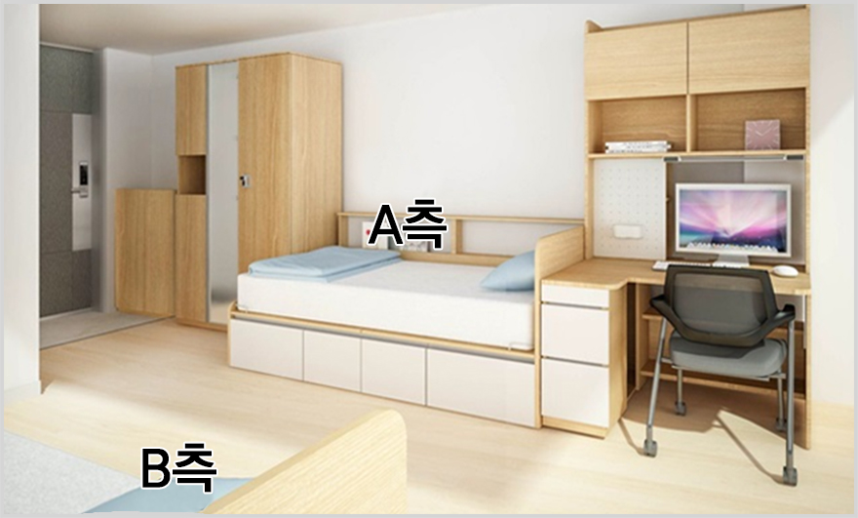

8. Additional Information
Visa | D-2-6 Visa  Please make sure to apply for a Student Visa(D-2-6) in home country before coming to Korea.

9. Useful Links for Getting Used to Seoul

Visit Seoul, Official Travel Guide
Travel Guidebooks and Maps  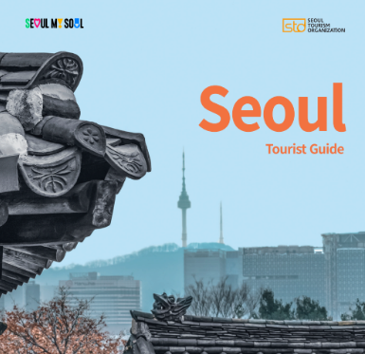 | Popular Spots  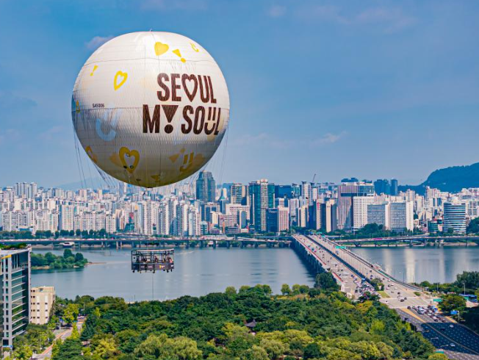
Transportation Guide  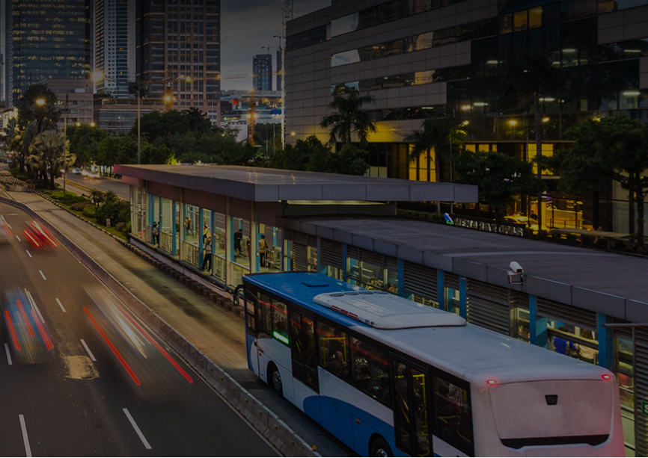 | Events  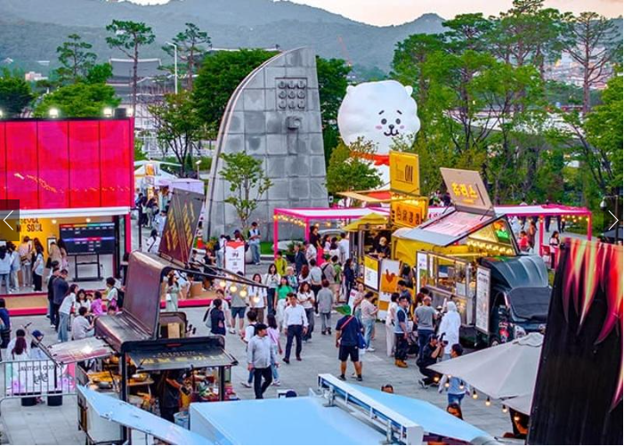

Living in Seoul (Multi-lingual) : Living in Seoul Booklet
Immigration information : HiKorea
National Health Insurance : Guidance for foreigners
Public transportation : Subway lines in Seoul

